Jeremy Thyn Multi-Modem System Report 7/23

HaLow Chip Testing:

To test the HaLow chip for embedding within the PCB, an SPI testing breakout is necessary to replicate the pin connections once on the same board as the CM5. Currently, I have been able to successfully connect the USB MM8108 from a CM5 to a router that is connected via ethernet to a NUC. The process for creating the HaLow functionality on the Pi goes as follows:

- Cloning the pi kernel and applying morse micro patches
- Building the kernel image, modules, and DTB’s
- Building the USB driver
- Installing the chip firmware and BCF file
- Point the Rpi bootleader to the custom kernel
- Build the wpa supplicant for sub 1G wifi
- Configure the wpa supplicant

The main things that will change with changing the chip to interface through SPI rather than USB is adjusting the driver and and ensuring that any further-down-the-pipeline changes are made that might be impacted by a driver difference. Additionally, creating a script that can automatically apply all of these changes to any raspberry pi cm5 will help streamline development.

The difficulty comes with the actual testing which will require a breakout board to connect to the SPI pins to the chip. Luckily, the cost is cheap with the MM8108-MF15457 only costing around $15-$25 and the rest of the parts for the breakout not being very expensive. Either I or Caleb can design this. Caleb will get it done faster, but he already has a lot of stuff to do.

Overall, the actual software setup will be relatively straightforward since I already figured out most of it, the main challenge is configuring the SPI driver and and downstream adjustments, as well as creating an automated script that can be used to replicate the setup. The hardware needs to be designed, fabricated, and finally delivered to actually test the chip, however.

Rebuilding the modem software integration:

Upon taking the time to review what was completed as a result of the ED project, the “final” versions of the code leave a lot to be desired. The best thing that can be done right now is a ground-up build of all of the features that were intended by the original code base, and just using the old code as scraps to base the new code off of. Here is a checklist that will be reflective of what the code needs to do (Note: this is all referenced from a generated guideline for how to execute the work to be done):

telemetry/
├── common/ # deployed identically to both Pis
│ ├── __init__.py
│ ├── config.py # YAML load + validation, incl. MAC invariants
│ ├── logsetup.py
│ ├── schema.py # SensorReading, Ack, Command, Status dataclasses
│ ├── framing.py # v2 typed codec: pack/unpack, CRC
│ ├── arbiter.py # Modem Arbiter — sole owner of the serial port
│ ├── mac.py # ImplicitTdmaMac — who may transmit, when
│ ├── acoustic.py # Popoto wrapper (was two files, tx and rx)
│ ├── peer.py # bidirectional NDJSON connection
│ ├── optical.py # local LUMA status poll + Peer connect/listen
│ ├── commands.py # registry, validation, execution
│ ├── linkmgr.py # switching policy
│ ├── spool.py # SQLite store-and-forward
│ └── supervise.py # supervised(), shutdown event, signal handling
├── node/ # the only entry point, on both Pis
│ ├── __init__.py
│ ├── main.py # §29.2
│ ├── context.py # NodeContext + handle_frame dispatcher
│ ├── sensor.py # SensorPort — iff capabilities.sensor
│ ├── video.py # GStreamer manager — iff capabilities.camera
│ └── influx.py # batched writer — iff capabilities.forwards_to_pc
├── tests/
│ ├── test_framing.py # extended for every frame type
│ ├── test_mac.py # window arithmetic, validation refusals
│ ├── test_commands.py # rejection paths, token guard
│ └── test_spool.py
├── tools/
│ ├── fake_sensor.py
│ ├── fake_modem.py
│ ├── fake_luma.py
│ └── virtual_channel.py # two nodes, one simulated medium
├── config/
│ ├── subsea.yaml # same schema, different values
│ └── surface.yaml
├── systemd/
│ └── telemetry-node.service
├── requirements.txt
└── README.md

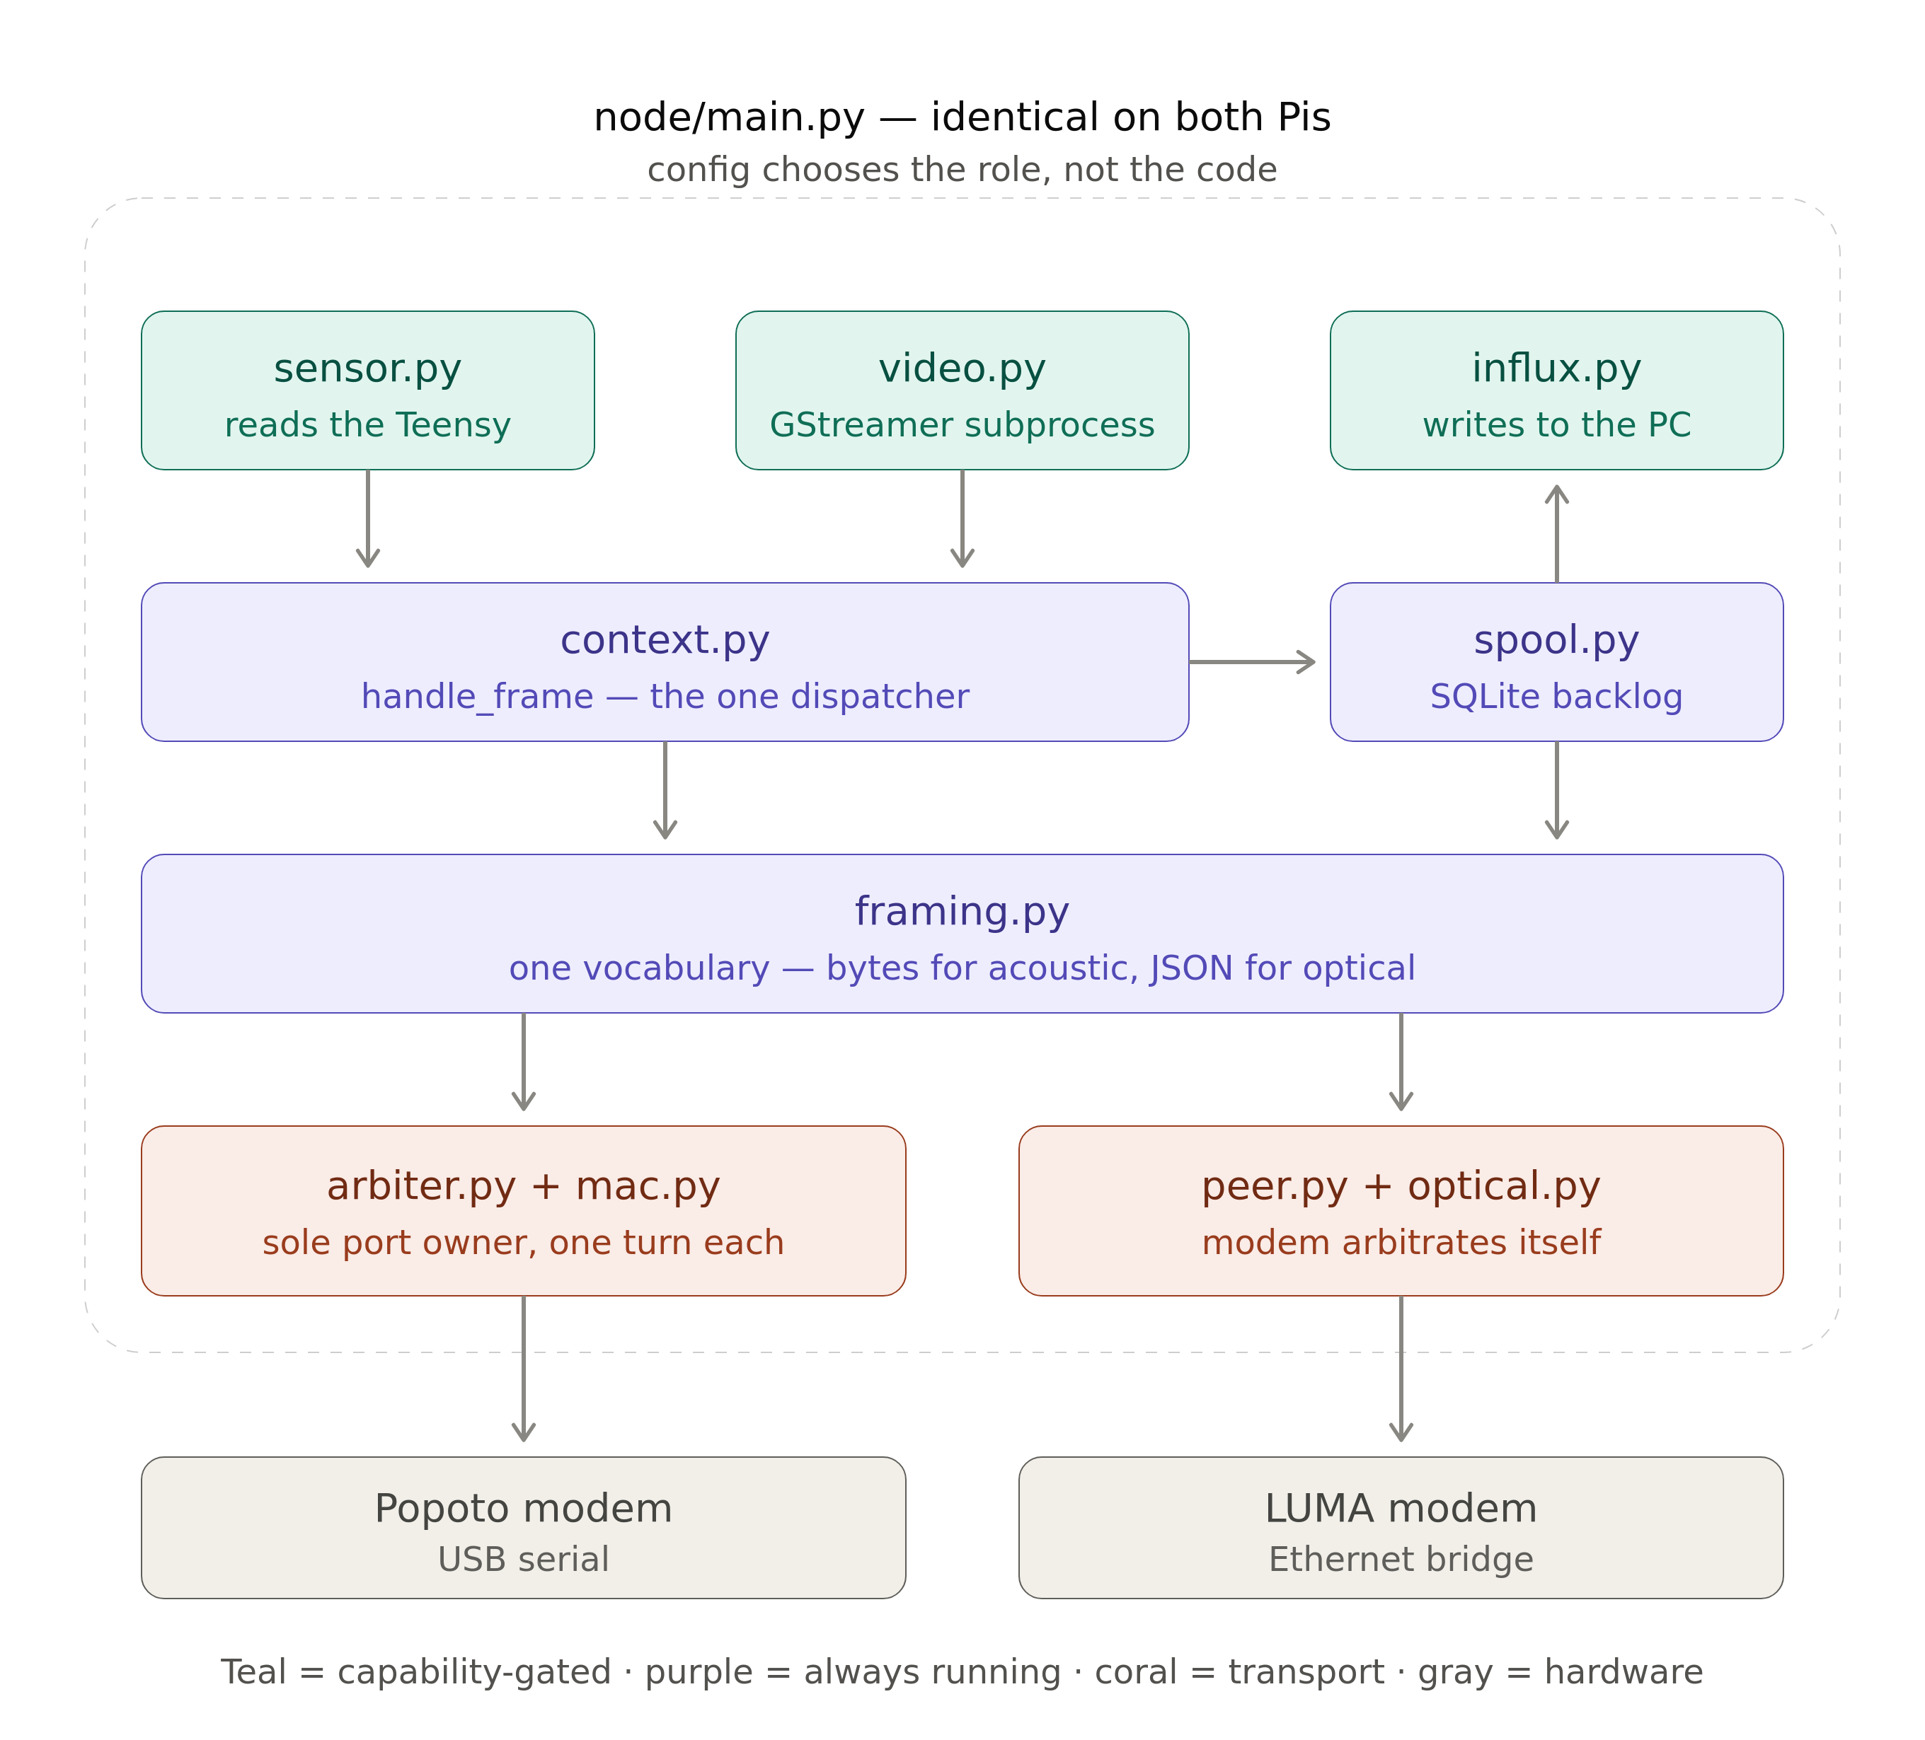

Phase 0 — Establish ground truth (half a day)
Goal: know what your library actually does, before you write code against it.
Tasks:
# 1. Find your real device paths
ls -l /dev/serial/by-id/

# 2. Introspect the Popoto module
python3 - << 'EOF'
import inspect, popoto_serial_v3 as m
cls = m.popoto
print("METHODS:", [n for n in dir(cls) if not n.startswith("_")])
print("\n--- __init__ ---"); print(inspect.signature(cls.__init__))
print("\n--- send ---"); print(inspect.getsource(cls.send))
print("\n--- transmitJSON ---"); print(inspect.getsource(cls.transmitJSON))
print("\n--- waitForReply ---"); print(inspect.getsource(cls.waitForReply))
print("\n--- getValueF ---"); print(inspect.getsource(cls.getValueF))
EOF

# 3. Talk to the modem and read a variable
python3 - << 'EOF'
from popoto_serial_v3 import popoto
p = popoto("/dev/serial/by-id/usb-FTDI_...", 115200, transport="serial")
p.isRemoteCmd = False
print("version:", p.getVersion(), p.waitForReply(5))
print("SNR:", p.getValueF("SNR"))
print("LocalID:", p.getValueI("LocalID"))
p.tearDownPopoto()
EOF

# 4. Capture the LUMA's real API shape — do NOT trust the manual here (§1.1)
for ep in general_info status parameters ip_address; do
echo "=== $ep ==="
curl -s --max-time 3 http://192.168.102.102/api/$ep.json | python3 -m json.tool
done

# 5. Resolve the throughput unit empirically: push a known rate and read back
# (run iperf3 -s on the far Pi first)
iperf3 -c 192.168.102.11 -b 1M -t 20 &
sleep 10 && curl -s http://192.168.102.102/api/status.json \
| python3 -c "import json,sys; d=json.load(sys.stdin); \
print({k:v for k,v in d.items() if 'throughput' in k})"
# 1 Mbit/s in → ~1000 means kbit/s, ~1000000 means bit/s

# 6. Verify the light path independently of your own code
curl -s -X POST http://192.168.102.102/api/comm_eval.json \
-H 'Content-Type: application/json' -d '{"message_write":"ping from subsea"}'
curl -s http://192.168.102.101/api/comm_eval.json # far modem, on its own network
Gate: you have written down, in a text file:
- (a) the exact signature of send, transmitJSON, and waitForReply;
- (b) the exact JSON the Popoto returns for a GetValue;
- (c) the exact JSON your LUMA returns for all four readable endpoints, with the actual key spellings — specifically whether the throughput/CRC/packet counters carry the _sec suffix or not;
- (d) the firmware version, API version, and processor ID of both LUMA units, and which is the X and which is the X-UV if they differ;
- (e) the resolved unit of throughput_received*;
- (f) confirmation that a comm_eval message crosses from one modem to the other.
Step (f) is the one worth insisting on. It proves the optical physical layer works using only the modems' own firmware — no Pi networking, no Python, no code you wrote. If it fails, nothing you build on top can succeed, and you've localized the problem to alignment, ambient light, IP configuration, or start_state before writing a line.

Phase 1 — Prove the acoustic byte path (one day)
Goal: confirm §8.1. This is the single highest-risk assumption in the whole design.
Bench setup: both modems in air, transducers 1–2 m apart, TxPowerWatts around 1–4. The manual notes an air test at ~4 W with 1–2 m spacing is appropriate, and warns that room multipath can produce CRC errors — pad reflective surfaces if needed.
Then repeat programmatically with a 106-byte frame from pack_frame() and compare byte-for-byte.
Gate: you can send an arbitrary 100+ byte binary frame and recover every byte identically at the receiver, at least 8 times out of 10. Write down the observed round-trip time.
If this gate fails, stop and solve it. Nothing downstream matters until bytes cross water intact.

Phase 2 — Framing library, offline (one day)
Goal: a tested common/framing.py with no hardware involved.
Write pack_frame/unpack_frame and the test suite from §10.3. Run pytest.
Gate: all tests pass, including corruption and truncation detection. pack_frame(MAX_RECORDS readings) is under 1000 bytes.

Phase 2b — Frame format v2 (half a day). Implement the typed codec and the extended tests. Gate: all of §26.3 passes, and every frame type fits one acoustic packet.

Phase 3 — Sensor acquisition, offline of modems (half a day)
Goal: the subsea Pi reads the Teensy reliably for 24 hours.
Write SensorPort (§6.1). Run a standalone script that reads at 1 Hz and appends to the spool. Leave it overnight.
Gate: after 24 hours: process still running, lsof -p <pid> | wc -l shows a stable descriptor count (proving no leak), spool row count matches expected within 1%, and unplugging/replugging the Teensy mid-run causes a logged reconnect rather than a crash.

Phase 4 — Acoustic telemetry end to end (two days)
Goal: readings from the Teensy appear on the surface Pi's console, via acoustics.
Wire together: SensorPort → queue → packetizer (batch 8, 30 s timeout) → acoustic_tx, and on the surface acoustic_rx → unpack_frame → print.
Gate: 100 consecutive frames sent; ≥95 decode successfully; sequence numbers show no gaps other than the ones you can account for; measured water time per frame matches your §10.4 budget within 20%.

Phase 4b — The arbiter (one day). Replace direct modem calls with ModemArbiter. Gate: transmit a frame while the peer is also transmitting toward you, and confirm both the TxComplete and the incoming {"Data":[...]} are handled — neither is swallowed. This is the specific defect §23.2 describes, and it's the reason this phase exists.

Phase 5 — Optical telemetry and NDJSON framing (one day)
Goal: the same readings, faster, over optical.
Implement send_frame/read_frames (§8.2). Add the ack channel.
Gate: deliberately send three frames back-to-back with no delay so they coalesce in one TCP segment, and confirm all three are received. Then kill the subsea process mid-connection and confirm the surface returns to accept() within 30 seconds rather than hanging.
If you're building the symmetric design, §31 inserts four extra phases into this plan (2b, 4b, 6b, 6c). Read it alongside this section rather than after it — Phase 2b replaces Phase 2's frame format outright, and building version 1 first is wasted work.

Phase 6 — Link management (one day)
Goal: automatic, non-flapping switching.
Implement LinkManager (§11.2). Test by physically blocking the optical path (a hand, a card) for varying durations.
Gate: blocking optical for 10 s produces at most one switch to acoustic and one back. Blocking for 5 minutes produces exactly one switch each way. Rapidly blocking/unblocking every 2 seconds produces no switching (dwell time holds).
Phase 6b — MAC validation (one day). Run the virtual-channel matrix above. Gate: zero collisions across every row; startup validation refuses every impossible configuration.
Phase 6c — Commands over the real link (half a day). Gate: from the surface, change the subsea PayloadMode and observe both the acknowledgement and the changed behaviour in the next frame. Then send a malformed command, a REBOOT with a wrong token, and an out-of-range SET_TX_POWER, and confirm all three are rejected and logged without side effects.

Phase 7 — Storage and forwarding (one day)
Goal: the surface Pi buffers and forwards to the PC.
Implement Spool and the HTTP export or push forwarder. Stand up InfluxDB + Grafana on the PC with Docker Compose (your modem-monitoring-pipeline.md covers this).
Gate: unplug the PC's network for 30 minutes. Spool grows. Reconnect. All buffered data arrives, in order, with correct original timestamps, and the spool drains to zero.

Phase 8 — Video (one day)
Goal: subsea camera visible at the surface and recording.
Gate: video runs for one hour. top on the subsea Pi shows the Python process under 5% CPU (proving the encode is in hardware and not in Python). Killing gst-launch-1.0 results in an automatic restart within 10 seconds.

Phase 9 — Autonomy (one day)
Goal: it survives everything in §3.4.
Install systemd units, enable the hardware watchdog, configure time.
Gate: the seven-item table in §18.6, every row passing.

Phase 10 — Soak (one week, unattended)
Goal: confidence.
Gate: seven days with no manual intervention. Memory usage flat (plot RSS over time — any upward slope is a leak). Spool bounded. No unexplained gaps in Grafana.

I am working of a generated guide to help with organizing my workflow and ideas, which is what is being referenced sometimes here.

